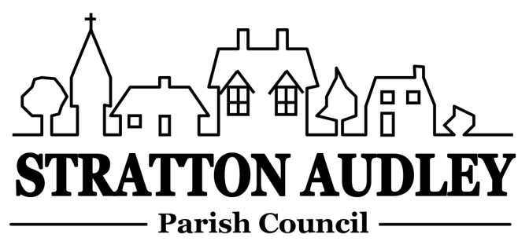
To Members of the Council: you are summoned to attend a meeting of Stratton Audley Parish Council on Wednesday 6th January 2016, in the Hunt Room of the Red Lion, Stratton Audley at 7.00pm
Members of the Public are welcome to attend

AGENDA

- Apologies for absence – to receive apologies for absence
- Declarations of interest – to receive any declarations of interest from Councillors
- To receive a presentation by Mr A Mobley relating to current plans for development at green Barn farm
- To receive Ms E Lewis-Edwards to consider Community Transport options
- Public participation – to receive questions from members of the public
- To receive and approve the Minutes of the Parish Council Meeting held on Wednesday 2nd December
- Update on progress from the Minutes – Clerk/Chairman will report on progress of outstanding items from previous meeting to include Christmas Tree and lights,
- Report from District and County Councillors – for information only
- Finance
  - To consider invoices for payment
  - To note the position with regard to the Council’s current and savings accounts
  - Parish Council budget/Precept
- Community Led Plan/Neighbourhood Plan
  - To receive an update on planned village events including the Festival in 2016 and to consider whether the Parish Council would wish to arrange an event to celebrate Queen Elizabeth ll’s 90th Birthday ( on the weekend of 11th/12th June)
  - To note that a group is now beginning to consider the requirements of a Neighbourhood Plan, and to authorise requests for funding this work to be made to DCLG.
- Village Website – report on activity.
- Parish Matters
  - Playground – to note progress in connection with the provision of a new Playground having accepted the grant offer from WREN of £26,000. Specifically to report on discussions with parents following further consultation on the equipment and surfacing to be used and to report on discussions with the preferred contractor to carry out the work.
  - To report on progress on the Resilience Grant proposals including a) the location of the defibrillator and b) the location of the storage shed.
  - To consider the progress of the development of a Village Emergency plan.
  - To consider Community transport options.
- Planning Applications/Decisions
None at present.
Notices of Decision
5 Willows Gate Stoke Lyne Road Stratton Audley 15/01421/ADV |amendment to earlier application – 1 fence mounted sign at the entrance to 5 Willows Gate – granted until 11th December 2016.
- Correspondence – to note correspondence received:
Request from the Lord Lieutenant of Oxfordshire to consider celebrating the Queen’s Birthday.
- Reports from meetings – to receive any reports from meetings
- Items for information or for the next agenda
- Date of next meeting – to confirm the date of the next meeting as Wednesday 10th February 2016 unless another date is agreed at the meeting.

Anne Davies, Clerk to the Council
6 Greystones Court, Kidlington Oxon OX51AR strattonaudley.parishclerk@gmail.com

