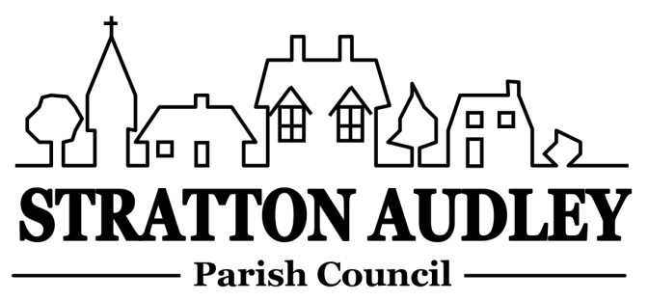
To Members of the Council: you are summoned to attend a meeting of Stratton Audley Parish Council on Wednesday 4th January 2017, in the Hunt Room of the Red Lion, Stratton Audley at 7.00pm

Members of the Public: you are invited to attend

AGENDA
To welcome Sunita Burke to explain the Neighbourhood Planning Process.

- Apologies for absence – to receive apologies and to note reasons for absence
- Declarations of interest – to receive any declarations of interest from Councillors relating to items on the Agenda, in accordance with the Council’s Code of Conduct
- Public participation – to receive questions and comments from members of the public.
- To receive and approve the Minutes of the Parish Council Meeting held on Wednesday 7th December 2016
- Update on progress from the Minutes – Clerk/Chairman/Councillors will report on progress of outstanding items which do not require further decision -road repairs beyond Pool Farm, the number 18 bus and congestion in Church Street, moving the concrete blocks by the disused Quarry site entrance, contacting OCC re reducing the height and size of the hedge on the Bicester Road by the fishing/recreational area.
- Report from District and County Councillors – for information only
- Finance
  - To receive the financial report – for information
  - To consider invoices for payment.
  - To agree the precept for 2017/18
- Parish Matters not otherwise mentioned under section 5 above:
  - Rural Transport –update
  - Installation date and works to install generator and defibrillator in the Church
  - Developing the Emergency Plan/vulnerable people list
  - Road Maintenance
  - Un-metalled footpaths and bridleways report
  - Setting up a fund for a Vehicle Activated Speed Sign for the village
  - Emergency Plan –Update
  - To consider adding photos of Councillors to their details on the web site/noticeboard.
- CLP update to include an activity schedule for 2017
- Planning Applications
- Conversion of a redundant squash court building in the grounds of Stratton Audley Hall to a 3 bedroom Dwelling
The Squash Court Stratton Audley Hall Bicester Road Stratton Audley
16/02277/F
- Correspondence received – to note correspondence received not otherwise on the agenda where decisions are not required
- Reports from meetings – to receive any reports; for information
- Items for information or next Agenda only – all items for the next agenda to be submitted to the Clerk by Friday 13th January 2017
- Date of next meeting – to confirm the date of the next meeting as Wednesday 1st February 2017

Anne Davies, Clerk to the Council
6 Greystones Court, Kidlington Oxon OX51AR strattonaudley.parishclerk@gmail.com

