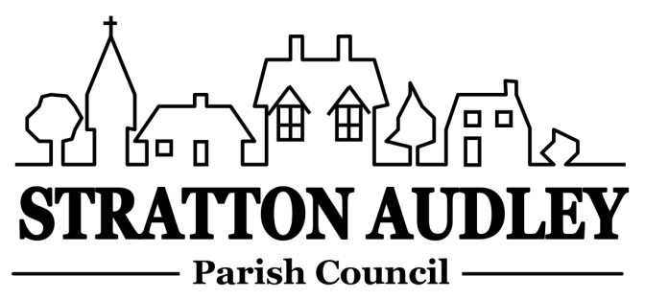
To Members of the Council: you are summoned to attend a meeting of Stratton Audley Parish Council on 2nd September, in the Hunt Room of the Red Lion, Stratton Audley at 7.00pm
Members of the Public are welcome to attend

AGENDA

- Apologies for absence – to receive apologies for absence
- Declarations of interest – to receive any declarations of interest from Councillors
- Public participation – to receive questions from members of the public
- To welcome the attendance at the meeting of Carol Mackay Principal Emergency Planning Officer for Oxfordshire to discuss Parish Emergency Plans and resilience.
- To receive and approve the Minutes of the Parish Council Meeting held on Wednesday 5th August 2015
- Update on progress from the Minutes – Clerk/Chairman will report on progress of outstanding items from previous meeting to include:- Bicester Rd path, street cleaning, burst pipe in Stoke Lyne Road, Village gates, dog bin bag dispensers and former Village Noticeboard.
- Report from District and County Councillors – for information only
- Finance
  - To consider invoices for payment
  - Budget 2015-2016 – to review and run through the approved budget for the current year
- Community Led Plan/ Social Fund raising Committee
  - To receive an update on events to include the Vintage Tea Party (Sunday 4th October 2015), the Halloween Children’s Party and the Food and Music Festival 2016.
  - To confirm progress on the wider Plan
- Village Website – to review the new Stratton Audley Village Web site, comment on content and move to approve.
- Parish Matters
- Playground – update.
- Remembrance Day Wreathe – The Parish Council has received an invitation from the Royal British legion to make a choice of wreathe for Remembrance Day by September 2015.
- SSE Resilience Fund – The Council has been made aware that a grant is available from SSE to support the Council with its plans to increase the resilience of the Village in the event of power cuts or hazardous weather conditions, and may want to make a submission for some support for the Village.
- Speed warning signage ( to discuss traffic speeding into the village and the potential future purchase of digital signs).
- Planning Applications
  - To consider all recent Applications appertaining to the Village
  - To note Notices of Decision
- Correspondence – to note correspondence received, including:
- Receipt of Cherwell District Council’s Local Plan
- OCC’s consultation on its Household Waste site strategy including the closure of the Household Waste and Recycling centre at Ardley from 2017
- Invitation to attend the Town and Parish Councils Event on 21 September
- Reports from meetings – to receive any reports from meetings, for information
- Items for information or for the next agenda
- Date of next meeting – to confirm the date of the next meeting as Wednesday7th October 2015

Anne Davies, Clerk to the Council
6 Greystones Court, Kidlington Oxon OX51AR strattonaudley.parishclerk@gmail.com

