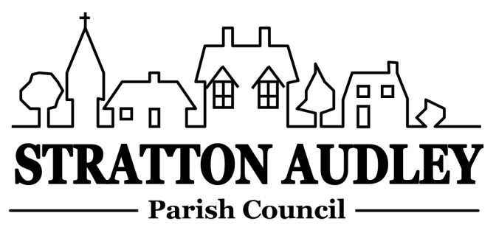
To Members of the Council: you are summoned to attend a meeting of Stratton Audley Parish Council on Wednesday 1st March 2017, in the Hunt Room of the Red Lion, Stratton Audley at 7.00pm

Members of the Public: you are invited to attend

AGENDA

- Apologies for absence – to receive apologies and to note reasons for absence
- Declarations of interest – to receive any declarations of interest from Councillors relating to items on the Agenda, in accordance with the Council’s Code of Conduct
- Public participation – to receive questions and comments from members of the public.
- To receive and approve the Minutes of the Parish Council Meeting held on Wednesday 1st February 2016
- Update on progress from the Minutes – Clerk/Chairman/Councillors will report on progress of outstanding items which do not require further decision -road repairs in the Parish including Mill Road, CDC’s response to OCC’s A Fresh Start for Oxfordshire – proposals for a Unitary authority.
- Report from District and County Councillors – for information only
- Finance
  - To receive the financial report – for information
  - To consider invoices for payment.
- Parish Matters not otherwise mentioned under section 5 above:
  - Rural Transport –update
  - Developing the Emergency Plan/priority people list (including SSE)
  - Road Maintenance
  - Un-metalled footpaths and bridleways report
  - Vehicle Activated Speed Sign – any update
  - Tree felling in a conservation area.
  - Annual Spring Clean
  - Playbus support funding
- CLP update
- Planning
Applications
None currently displayed
Decisions
None
- Correspondence received – to note correspondence received not otherwise on the agenda where decisions are not required:- CDC’s survey of community facilities
- Reports from meetings – to receive any reports; for information
- Items for information or next Agenda only – all items for the next agenda to be submitted to the Clerk by Sunday 20th March 2017
- Dates for Open Meeting/Annual Meeting (in May)
- Date of next meeting – to confirm the date of the next meeting as Wednesday 5th April 2017 and to consider the date of the Open Meeting

Anne Davies, Clerk to the Council
6 Greystones Court, Kidlington Oxon OX51AR strattonaudley.parishclerk@gmail.com

