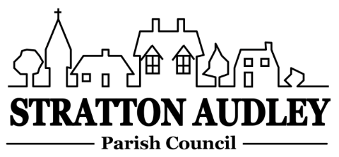
To Members of the Council: you are summoned to attend a meeting of Stratton Audley Parish Council on Wednesday 6th June 2018, in the Hunt Room of the Red Lion Public House , Stratton Audley at 7.00pm
Members of the Public: you are welcome to attend.
AGENDA
- Apologies for absence – to receive apologies and to note reasons for absence
- Declarations of interest – to receive any declarations of interest from Councillors relating to items on the Agenda, in accordance with the Council’s Code of Conduct
- Public participation – to receive other questions and comments from members of the public.
- To receive and approve the Minutes of the Parish Council Meeting held on Wednesday 2nd May 2018 and Wednesday 9th May 2018
- Update on progress from the Minutes – Clerk/Chairman/Councillors will report on progress of outstanding items which do not require further decision – commercial vehicle on Church Street, the Mallories development, playground repairs, data/email privacy requirements, chicanes in Bicester.
- Finance
  - To receive the financial report – for information
  - To consider invoices for payment.
  - To agree the parish Council accounts for 2017/18
  - To agree the Corporate Governance statement for 2018
  - To agree the Audit Exemption certificate for 2018
  - To note the content of the Internal Auditor’s report
- Parish Matters not otherwise mentioned under section 5 above:
  - Road Maintenance – pot holes
  - Mezzanine Floor( storage) in the Church
  - Resilience Grant
  - Dog bins/Litter bins upgrade
  - Individual Councillor roles/responsibilities
  - Councillor email accounts
  - Village Improvement Funds
  - Un-metalled footpaths and bridleways report
  - Mobile connectivity
- CLP update – Festival 2018
- Planning –
Applications
None
Appeal
2 Garden Cottages West Street APP/C3105/W/18/3194358
Decisions
- Parish Correspondence received –
OCC update
Date for OCC/Parish Councils liaison meeting
- Reports from meetings –
- Items for information or next Agenda only – all items for the next agenda to be submitted to the Clerk by 15th June 2018
- Date of next meeting – 4th July 2018

Anne Davies, Clerk to the Council
6 Greystones Court, Kidlington Oxon OX51AR strattonaudley.parishclerk@gmail.com
18th May 2018

