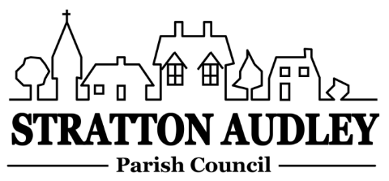
To Members of the Council: you are summoned to attend a meeting of Stratton Audley Parish Council on Wednesday 6th February 2019, in the Hunt Room of the Red Lion Public House , Stratton Audley at 7.00pm
Members of the Public: you are welcome to attend.

AGENDA
- Apologies for absence – to receive apologies and to note reasons for absence

- Declarations of interest – to receive any declarations of interest from Councillors relating to items on the Agenda, in accordance with the Council’s Code of Conduct

- Public participation – to receive other questions and comments from members of the public.

- To receive and approve the Minutes of the Parish Council Meeting held on Wednesday 9th January 2019.

- Update on progress from the Minutes – Clerk/Chairman/Councillors will report on progress of outstanding items which do not require further decision – Church storage, First aid training, Launton Road pot holes, Horse signs, East West Rail update, maintenance proposals, Bicester Heritage planning update Hotel and technical site(if any), Quarry update(if any), Oxford to Cambridge expressway.

- Finance
  - To receive the financial report – for information
  - To consider invoices for payment

- Parish Matters not otherwise mentioned under section 5 above:
  - Village Improvement Fund –Any other suggestions?
  - Un-metalled footpaths and bridleways report
  - VAS update
  - SA Community Emergency Plan – Final sign off
  - Oxford Wild Life Trust initiative/
  - Pocket Park grant application – The pound area
  - Pond Path Access/refurbishment .
  - “Keep Clear” bollards
  - Conservation Area Review

- CLP update –proposals for the year 2019.

- Planning –
None

- Parish Correspondence received –
OCC Update

- Reports from meetings
None

- Items for information or next Agenda only – all items for the next agenda to be submitted to the Clerk by 14th February 2019

- Date of next meeting – 5th March 2019. To confirm the date of the Annual Parish Meeting as 9th April 2019.

Anne Davies, Clerk to the Council
6 Greystones Court, Kidlington Oxon OX51AR strattonaudley.parishclerk@gmail.com
21st January 2019

