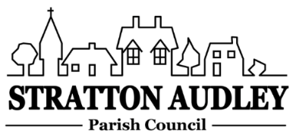
To Members of the Council: you are summoned to attend a meeting of Stratton Audley Parish Council on Wednesday 1st May 2019, in the Hunt Room of the Red Lion Public House , Stratton Audley at 7.00pm
Members of the Public: you are welcome to attend.
AGENDA
- Apologies for absence – to receive apologies and to note reasons for absence
- Election of Chairman and Appointment of Vice Chairman
- Declarations of interest – to receive any declarations of interest from Councillors relating to items on the Agenda, in accordance with the Council’s Code of Conduct
- Public participation – to receive other questions and comments from members of the public.
- To receive and approve the Minutes of the Parish Council Meeting held on Wednesday 3rd April 2019.
- Update on progress from the Minutes – Clerk/Chairman/Councillors will report on progress of outstanding items which do not require further decision –Outcome of Annual Parish Meeting/Volunteers, litter bin on Mill Road hill, Oxford Wild Life Trust initiative, East West Rail update, road sign by the Mallories, meeting with the Church on 8th May, traffic cones by the Church, welcome pack.
- Finance
  - To receive the financial report – for information
  - To consider invoices for payment
  - To agree the accounts for the year 2018/19 together with the Corporate Governance statement.
- Parish Matters not otherwise mentioned under section 5 above:
  - Conservation Area Review – discuss and agree formal response
  - Village Improvement Fund - village entrance troughs, new benches, flag pole, Bucks Way stile and any other suggestions from the Annual Parish Meeting.
  - Pond Path Access/refurbishment
  - Purchase of second VAS update/funding application
  - Purchase and location of second defibrillator
  - Pound Pocket Park - update
  - Fibre Broadband in the Parish
  - Next Door Drop mid May
- CLP update –any new proposals for the years 2019/20.
- Planning –
None
- Parish Correspondence received –
OCC Update
OALC Update
- Reports from meetings
- Items for information or next Agenda only – all items for the next agenda to be submitted to the Clerk by 14th May 2019
- Date of next meeting – 5th June 2019.
Anne Davies, Clerk to the Council
6 Greystones Court, Kidlington Oxon OX51AR strattonaudley.parishclerk@gmail.com

24th April 2019

