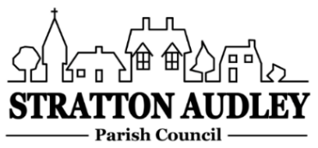
To Members of the Council: you are summoned to attend a meeting of Stratton Audley Parish Council on Wednesday 5th February 2020, in the Hunt Room of the Red Lion Public House, Stratton Audley at the time of 7.00pm. Members of the Public are always welcome to attend.

AGENDA
- Apologies for absence – to receive apologies and to note reasons for absence
- Declarations of interest – to receive any declarations of interest from Councillors relating to items on the Agenda, in accordance with the Council’s Code of Conduct
- Public participation – to receive other questions and comments from members of the public.
- To receive and approve the Minutes of the Parish Council Meeting held on Wednesday 7th January 2020
  - Update on progress from the Minutes – Clerk/Chairman/Councillors will report on progress of outstanding items which do not require further decision – Thames Water drain survey, Second VAS, Footpath gate off Stoke Lyne Road, Bicester Heritage generally, Oxford to Cambridge Expressway, EWR update, village pot holes, path resurfacing by the Pond, PRW path near hunt kennels, Cross Bucks Way footpath gravel
- Finance
  - To receive the financial report – for information
  - To consider invoices for payment
- Parish Matters not otherwise mentioned under section 5 above:
  - Rear Church Yard entrance accessibility
  - SSEN Resilience grant application
  - Playground inspection report
- CLP update
  - None planned
  - VE Day 75th Anniversary on 8th May
- Planning –
As registered at the date of the next meeting.
- Parish Correspondence received –
OCC Update
OALC Update
- Reports from meetings –
None.
- Items for information or next Agenda only – all items for the next agenda to be submitted to the Clerk by 14th February 2020
- To agree that the date of the next meeting.

Anne Davies, Clerk to the Council
6 Greystones Court, Kidlington Oxon OX51AR strattonaudley.parishclerk@gmail.com
31/12/19

