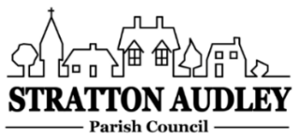
To Members of the Council: you are invited to attend an informal virtual meeting of Stratton Audley Parish Council on Wednesday 3rd f June 2020 at 7.00pm. Meeting details and password will be circulated by invitation prior to the start of the meeting.

AGENDA
- Apologies for absence – to receive apologies and to note reasons for absence
- Declarations of interest – to receive any declarations of interest from Councillors relating to items on the Agenda, in accordance with the Council’s Code of Conduct
- Update on Parish matters
Thames Water drain survey
Resurfacing part of Launton Road
Path improvements
SSE Resilience Grant
Update on Annual parish Meeting and Annual Parish Council meeting
Virtual Meetings
- Corona virus update
- Finance
  - To consider invoices for payment
- Parish Matters not otherwise mentioned under section 5 above:
EWR – Light Goods Vehicles through the village
Cycle Path on A4421 – OCC & CDC new monies
Bicester Motion development plans
Church Clock Repair – cost of survey
CLP - Street Party Event
- Planning –
As registered at the date of the next meeting.
- Items for information or next Agenda only – all items for the next agenda to be submitted to the Clerk by 14th June 2020
- The date of the next meeting – to be agreed.

Anne Davies, Clerk to the Council
6 Greystones Court, Kidlington Oxon OX51AR strattonaudley.parishclerk@gmail.com
26/5/20

