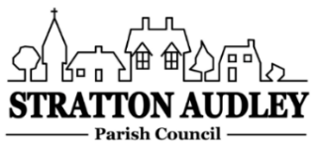
To Members of the Council: you are summoned to attend a virtual meeting of Stratton Audley Parish Council on Wednesday 3rd March 2021 at 7.00pm. Meeting details and password will be circulated by invitation prior to the start of the meeting.

AGENDA
- Apologies for absence – to receive apologies and to note reasons for absence
- Declarations of interest – to receive any declarations of interest from Councillors relating to items on the Agenda, in accordance with the Council’s Code of Conduct
- To approve the minutes of the previous meeting
- Update on Previous Parish matters
- Allotments
- Tree Planting
- Surface Water Flooding
- Thames (Foul) Water
- Road resurfacing
- EWR update including road closures
- Corona virus update
- Finance
  - To consider invoices for payment
  - To note the Council’s current financial position
- Parish Matters not otherwise mentioned under section 5 above:
- Bus Service – John Charlton OCC to attend
- Containing Outbreaks Fund
- Village survey and 10 Year Census
- Revised Conservation Area report
- Waste land – Top of Stoke Lyne Road
- Litter picking/protection of verges/wild flower planting
- Village activities 2021
- Planning –
As registered at the date of the meeting.
20/0349/F change of use?
20/034/26/F Green Barn Plot 3 application refusal?
Bicester Motion?

- Items for information or next Agenda only – all items for the next agenda to be submitted to the Clerk as soon as possible please.
- The date of the next meeting – 5th May 2021.

Anne Davies, Clerk to the Council
6 Greystones Court, Kidlington Oxon OX51AR strattonaudley.parishclerk@gmail.com

