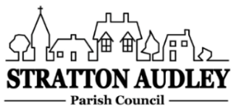
To Members of the Council: you are summoned to attend a virtual meeting of Stratton Audley Parish Council on Tuesday 16th March 2021 at 6.00pm. Meeting details and password will be circulated by invitation prior to the start of the meeting.

AGENDA
- Apologies for absence – to receive apologies and to note reasons for absence
- Declarations of interest – to receive any declarations of interest from Councillors relating to items on the Agenda, in accordance with the Council’s Code of Conduct
- Planning –
- 21/00519/F | 3 The Green Barn Stoke Lyne Road Stratton Audley Bicester OX27 9AT | RETROSPECTIVE - Erection of new detached  dwelling  house - this application seeks to amend the  original  dwelling design from 16/00366/REM and  Appeal APP/C3105/W/16/3154107 –  re-submission of 20/03426/F

- The date of the next meeting – 5th May 2021.

Anne Davies, Clerk to the Council
6 Greystones Court, Kidlington Oxon OX51AR strattonaudley.parishclerk@gmail.com

