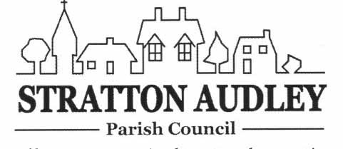

Minutes of the special meeting of Stratton Audley Parish Council on Tuesday 16th March 2021
Present: Mr J Honsinger (Chairman) Mrs K Walker and Ms M Ling

Apologies: Mr A Flack (Vice Chairman), Mr M Hedgecox, and Mr M Gore.

Also present: Members of the public: None

Declarations of Interest
Cllr Honsinger declared a personal interest in the Green Barn planning application as the owner of a neighbouring property.

- Planning
21/00519/F | 3 The Green Barn Stoke Lyne Road Stratton Audley Bicester OX27 9AT | RETROSPECTIVE - Erection of new detached dwelling  house - this application seeks to amend the original  dwelling design from 16/00366/REM and Appeal APP/C3105/W/16/3154107 - re-submission of 20/03426/F  To be discussed when the official submission is received and circulated. | 16/02/2021 | Under Consultation

After discussion the Parish Council formed the view that:

The resubmission of the retrospective planning application has now been considered by Stratton Audley Parish Council, which has expressed concern that the reason for refusal of the previous application before the planning committee on 11th February 2021 has not been displayed on the Cherwell DC website, and furthermore, despite the refusal, the new application is to be decided by officers under their delegated powers.

The Parish Council has noted that the Committee minutes state that the decision to refuse was ‘due to the interrelationship of the building with the surrounding conservation area, the design and orientation of the building in the context of which it was set and the loss of amenity due to the additional windows.” It was thought to be too urban looking.

The new application 21/00519/F purports to address one of the reasons minuted with the removal of most of the side windows. The Parish council welcomes the removal of most of these windows but has concerns over the manner in which the other reasons for rejection by the committee will be dealt with and understands from a conversation with the Planning Officer that no other action is proposed to address committee concerns.

Stratton Audley believe that the Green Barn development is a key site at a major entry point into the village, and, being joined to the conservation area, visually sets the scene for entry into the village from the Stoke Lyne Road. The comparator often used by the developer during this development is Cherry Cottage, and it is the Parish Council’s view that the current proposed style of the windows is too contemporary and does not reflect that of Cherry Cottage or the majority of properties in the village. The Developer will argue that they are the same design as the other windows on this development but they do not have significant prominence. The Parish Council suggests that a more appropriate style would be a traditional window frame with latticed panes for the road side windows as this would help with the overall fenestration of the building and reflect the windows of Cherry Cottage. It will also go some way to address the general concerns of the CDC Planning Committee to the overall design of the property.

The Parish Council notes that the side passage directly onto the road between the garages is to be closed so as to appear as a continuous stone wall.

On this basis Stratton Audley Parish council would urge that, in the event that an officer exercising delegated powers is minded to recommend approval of the application, that a condition is attached to the design of the front windows as outlined above, or that the application is referred back to the CDC Planning Committee for determination.

Date of next meeting
5th May 2021 at 7.00pm. Most likely another virtual meeting where members of the public will be able to request joining it by contacting the Clerk. Prior to this special meeting to discuss the new application for plot 3 of the Green Barn.

strattonaudley.parishclerk@gmail.com
www.strattonaudley.org. See also Facebook – strattonaudleyparishcouncil

