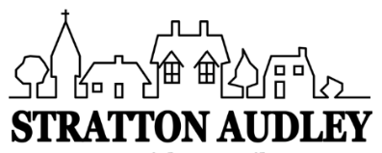
LOCAL GOVERNMENT ACT 1972
NOTICE OF ANNUAL PARISH OPEN MEETING
FOR STRATTON AUDLEY

NOTICE IS HEREBY GIVEN THAT
The Annual Assembly of the Parish Meeting for Stratton Audley will be held at St Mary and St Edburga Church on Wednesday 4th August 2021 at 7.30pm.

This is not to be confused with the Annual Parish Council Meeting but an OPEN meeting of the Parish. The Parish Council traditionally facilitates the meeting and creates a running order to include current matters known to be of interest to the community. However any relevant matters can be raised for discussion at the meeting by any member of the Parish.

Covid Mask Wearing Notice
The Parish Council will not be wearing masks during the meeting. However the current church policy on using the building is to request that people entering and leaving it do wear one. It is not obligatory, but please be sensitive to others who may be feeling much less confident about the lifting of restrictions than you.

Local Government electors for the village will be entitled to vote at the Meeting which will be open to the public.

The business to be transacted at the meeting will be as follows:
- Chairman’s Welcome
- Apologies
- Minutes of the last Annual Parish Meeting (2019)
- Report by the Clerk about the year 2019-2021
- Report By Ian Corkin about CDC & OCC issues
- Current Matters before the Parish Council
- Platinum Jubilee Celebrations 2022
- Open forum and discussion - Potential topics:
Bicester Motion; Thames Water; Stoke Lyne Road Waste land Re-wilding project; 20 MPH village wide speed restriction; The Red Lion; Tree planting; allotments; wild flower areas; grass cutting; Purchase of Red Telephone box; Speed patrols; more speed awareness signs.
- Any other business

John Honsinger
Parish Council Chairman
28nd July 2021

