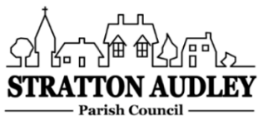
To Members of the Council: you are summoned to attend a meeting of Stratton Audley Parish Council on Wednesday 19th January 2022 at 7.00pm in the Hunt room of the Red Lion PH.

AGENDA
- Apologies for absence – to receive apologies and to note reasons for absence
- Declarations of interest – to receive any declarations of interest from Councillors relating to items on the Agenda, in accordance with the Council’s Code of Conduct

- To approve the minutes of the previous meeting

- Update on Previous Parish matters
BM Experience Quarter Planning Application, Defibrillator registration; EWR general update; proposal for a path along the Bicester Road; children’s safety poster campaign; Lyne road triangle improvement

- Finance
  - To consider invoices for payment
  - To note the Council’s current financial position
  - To agree the precept for 2022/2023

- Parish Matters not otherwise mentioned under section 5 above:
- Speed monitoring equipment/speed calming initiatives
- Village questionnaire
- Platinum Jubilee 2-5 June 2022 committee members and planning update
- Weed Spraying Contract
- CDC charge for brown bin waste
- Horse riders on phones
- Playground annual inspection
- Speed camera maintenance contract

- Planning –
- Planning Applications and decisions as registered at the date of the meeting.
- Report from Meetings – None

- Items for information or next Agenda only – all items for the next agenda to be submitted to the Clerk as soon as possible please.

- The date of the next meeting:
2nd March 2022

Anne Davies, Clerk to the Council
6 Greystones Court, Kidlington Oxon OX51AR strattonaudley.parishclerk@gmail.com

