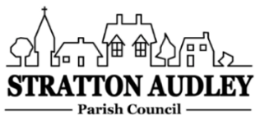
To Members of the Council: you are summoned to attend a meeting of Stratton Audley Parish Council on Wednesday 2nd March 2022 at 7.00pm in the Hunt room of the Red Lion PH.

AGENDA
- Apologies for absence – to receive apologies and to note reasons for absence
- Declarations of interest – to receive any declarations of interest from Councillors relating to items on the agenda, in accordance with the Council’s Code of Conduct

- To approve the minutes of the previous meeting

- Update on Previous Parish matters
BM Experience Centre; EWR general update; proposal for a path along the Bicester Road; children’s safety posters; Stoke Lyne Road waste land; entrance gate repairs; new Weed Spraying Contract.

- Finance
  - To consider invoices for payment
  - To note the Council’s current financial position

- Parish Matters not otherwise mentioned under section 5 above:
- Speed monitoring survey/speed calming initiatives/20mph application
- Re-seeding Pound wildflower area
- Village questionnaire update
- Platinum Jubilee 2-5 June 2022 planning update, including recent correspondence.
- Buy local policy and change to financial regulations
- Playground annual inspection
- Road markings
- Defibrillator & first aid training
- Revised Conservation Area

- Planning –
- Planning Applications and decisions as registered at the date of the meeting.
- Report from Meetings – None

- Items for information or next Agenda only – all items for the next agenda to be submitted to the Clerk as soon as possible please.

- The date of the next meeting:
6th April 2022

Anne Davies, Clerk to the Council
6 Greystones Court, Kidlington Oxon OX51AR strattonaudley.parishclerk@gmail.com

