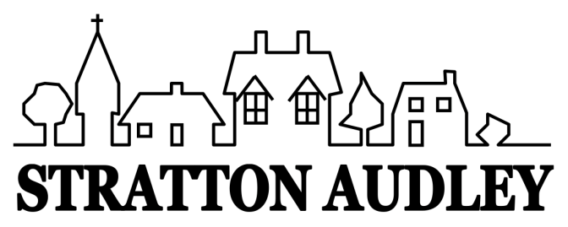
LOCAL GOVERNMENT ACT 1972
NOTICE OF ANNUAL PARISH OPEN MEETING
FOR STRATTON AUDLEY

NOTICE IS HEREBY GIVEN THAT
The Annual Assembly of the Parish Meeting for Stratton Audley will be held at St Mary and St Edburga Church on Wednesday 6th April 2022 at 7.30pm.
This is not to be confused with the Annual Parish Council Meeting but an OPEN meeting of the Parish. The Parish Council traditionally facilitates the meeting and creates a running order to include current matters known to be of interest to the community. However any relevant matters can be raised for discussion at the meeting by any member of the Parish.
Local Government electors for the village will be entitled to vote at the Meeting which will be open to the public.
The business to be transacted at the meeting will be as follows:
- Chairman’s Welcome
- Apologies
- Minutes of the last Annual Parish Meeting
- Report by the Clerk about the year 2021-2022
- Report about Cherwell District Council issues
- Report from The Church and other local groups
- Results of recent village survey & traffic monitoring
- Open forum and discussion on any matter of interest
- Any other business

John Honsinger
Parish Council Chairman
30th March 2022

