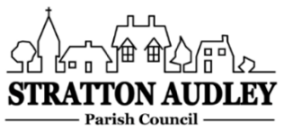
To Members of the Council: you are summoned to attend a meeting of Stratton Audley Parish Council on Wednesday 1st June 2022 at 7.00pm in the Red Lion Public house

AGENDA
- Apologies for absence – to receive apologies and to note reasons for absence
- Declarations of interest – to receive any declarations of interest from Councillors relating to items on the agenda, in accordance with the Council’s Code of Conduct
- To approve the minutes of the previous meeting
- Update on Previous Parish matters
BM Experience Quarter Conditions; EWR general update; entrance gate repairs; defibrillator training update, hire of noise monitoring equipment, church clock, power cuts update, Platinum Jubilee update including tree purchase

- Finance
  - To consider invoices for payment
  - To note the Council’s current financial position

- Parish Matters not otherwise mentioned under section 5 above:
- Co-0ption of new Parish Councillors
- No-path signage on Bicester Road
- Village questionnaire analysis, further update
- Jubilee Tree purchase
- Community shop
- Bicester motion activities

- Planning –
Planning Applications and decisions as registered at the date of the meeting.
- I West Cottages
- I The Manor Mews

- Report from Meetings – None
- Items for information or next Agenda only – all items for the next agenda to be submitted to the Clerk as soon as possible please.
- The date of the next meeting:
6th July 2022

Anne Davies, Clerk to the Council
6 Greystones Court, Kidlington Oxon OX51AR strattonaudley.parishclerk@gmail.com

