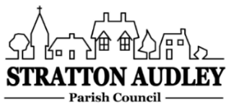
To Members of the Council: you are summoned to attend a meeting of Stratton Audley Parish Council on Wednesday 3rd November 2021 at 7.00pm in the Hunt room of the Red Lion PH.

AGENDA
- Apologies for absence – to receive apologies and to note reasons for absence

- Declarations of interest – to receive any declarations of interest from Councillors relating to items on the Agenda, in accordance with the Council’s Code of Conduct

- To approve the minutes of the previous meeting

- Update on Previous Parish matters
Pot Holes; repair to path by Pond; defibrillator in church; Speed Camera Data; EWR Park Rd to Poundon;

- Finance
  - To consider invoices for payment
  - To note the Council’s current financial position

- Parish Matters not otherwise mentioned under section 5 above:
- Biceterbug meeting re Bicester Motion Application
- Village wide speed restriction options including OCC policy update
- Village questionnaire
- Historical Parish Council documents
- Proposal for path on Bicester Road
- Church Tower flag pole estimate
- Platinum Jubilee 2-5 June 2022 Planning update
- Bicester Jubilee Meeting
- CDC Parish Liaison Meeting 10/11/21

- Planning –
- Planning Applications and decisions as registered at the date of the meeting

- Items for information or next Agenda only – all items for the next agenda to be submitted to the Clerk as soon as possible please.

- The date of the next meeting to be agreed as 1st December.

Anne Davies, Clerk to the Council
6 Greystones Court, Kidlington Oxon OX51AR strattonaudley.parishclerk@gmail.com

