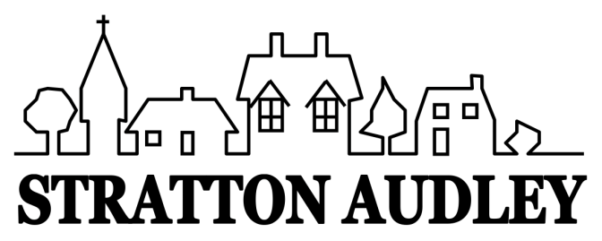
LOCAL GOVERNMENT ACT 1972
NOTICE OF ANNUAL PARISH OPEN MEETING
FOR STRATTON AUDLEY
NOTICE IS HEREBY GIVEN THAT
The Annual Assembly of the Parish Meeting for Stratton Audley will be held at St Mary and St Edburga Church on Wednesday 19th April 2023 at 7.00pm.
This is not to be confused with the Annual Parish Council Meeting but an OPEN meeting of the Parish. The Parish Council traditionally facilitates the meeting and creates a running order to include current matters known to be of interest to the community. However any relevant matters can be raised for discussion at the meeting by any member of the Parish.
Local Government electors for the village will be entitled to vote at the Meeting which will be open to the public.
The business to be transacted at the meeting will be as follows:
- Chairman’s Welcome
- Apologies
- Minutes of the last Annual Parish Meeting
- Report by the Clerk about the year 2022-2023
- Report from The Church / CDC if any
- For Discussion:
- Solar Farm Development
- Bicester Motion Experience Quarter
- The Red Lion
- EWR
- Ideas for Village Improvement Fund
- Open forum
- Any other business

John Honsinger
Parish Council Chairman
12 April 2023

